**Jan Brown times 16th June 2025**

Polite reminder –

* Ensure all droppings are removed from the car park area
* Do not feed hay outside of your box
* Do not leave horses unattended tied up outside your boxes

**Please check your phone prior to travelling for text/email messages just in case the lesson is cancelled due to unforeseen circumstances**

**PLEASE CALL ME - 07775681550 IF YOU HAVE ANY ISSUES**

3pm

Rachel

Jasmine

4pm

Alexandra

Maxine

5pm

Lauren

Jill

Elaine

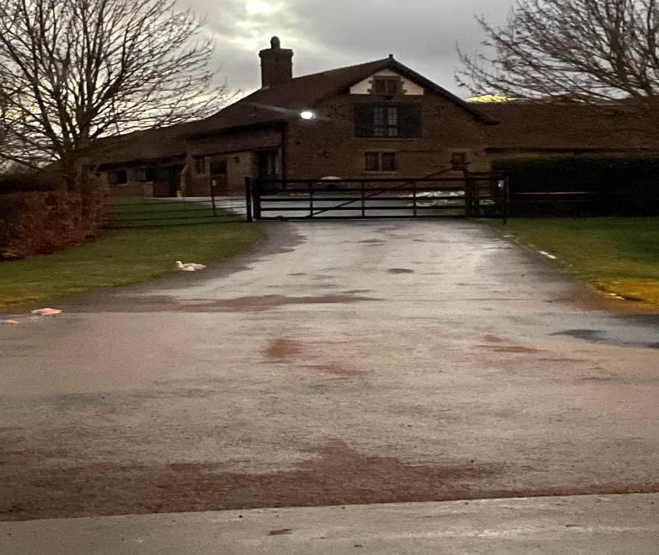

The address is – Home Farm Kirk Hammerton YO26 8BX

What3words: ///handlebar.released.newly

There is a low bridge near Cattal so if you are coming from the Harrogate direction along the A59, keep going past Green Hammerton and after Benson Furniture which is on the right take the next right turning onto Station road, this will take you through Kirk Hammerton and the entrance to Home Farm will be on your left hand side.The main gates are electric but they open automatically as you approach. Go past the stables and then just follow the track all the way to the bottom where the indoor arena is.

You can park either by the indoor arena or in the carpark on your right just before you come down to the indoor

See you all on Monday